Nicholas Skinner

5/30/2017

Assignment 4

**Development of Testers:**

**Appt:**

Appt was mostly written for us to get a better idea of how to go about creating these tests, and still needed strings for both the title, and the description. To get the program to create a random string for us to use, we just needed to call the ValuesGenerator.getstring() method. We then need to set the to be to be the appt’s newTitle

**CalDay:**

This one was a bit more complicated, as we had to start from scratch, I started by creating a string to specify the methods that we will be testing in the appt class, as the requirements for this are mostly similar to each other, it's just a difference of validating the parameters passed vs adding the parameters to our linked list.

My next step was to create an iterative loop that will test until the program times out, and will create values by referencing the values generator, after this, they will be added to an appt object, and then sent to check whether it will be going to isValid or addAppt, then we will display the times we created tests at the end of the loop

**TimeTable:**

Time Table was much the same, we had to start from scratch, and it was mostly similar to the CalDay creation, main difference had been that we need to change how to handle the created variables, I had set up a system to add the items to the appt list, and then delete them to see if the Time Table was capable of doing what it needed to

**Code failed to cover:**

My code managed to have complete line coverage of the methods that were required according to cobertura, I am unsure how to display branch coverage for just a few methods. I have attached pictures of the methods coverage when looked at in cobertura.

Final coverage screenshot:

**Appt isValid**

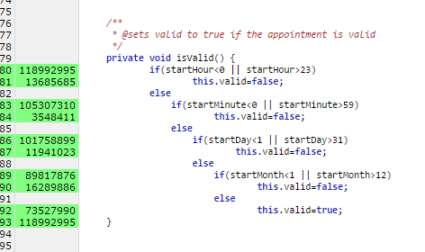

**Appt setDescription**

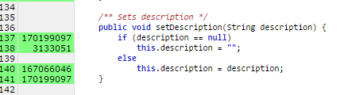

**Calday addAppt**

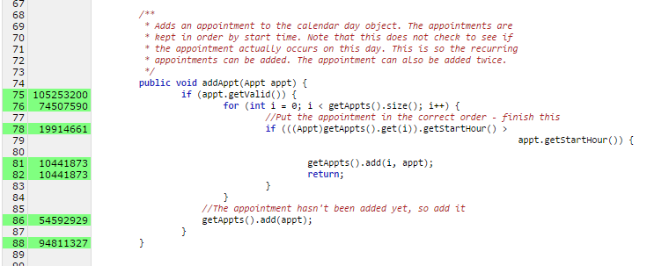

**TimeTable Delete Linked List**

